Wootton St Peter’s CE Primary School

Behaviour Policy
Date Adopted by Governing Body: September 2025
Date to be Reviewed: September 2026
Signed Chair of Governors
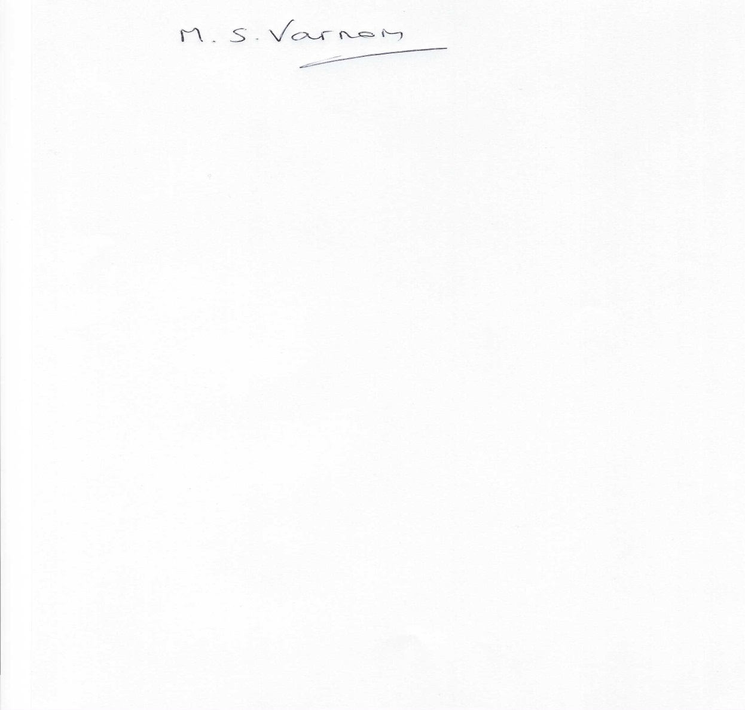

Mike Varnom

Signed Headteacher
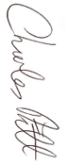

Charles Pitt

Wootton St Peter’s CE Primary School Behaviour Policy

At Wootton St Peter’s we aim to create a caring and calm environment and promote our school values of perseverance, compassion and courage. We have high expectations and strive to achieve a level of excellence in all that we do. The behaviour at our school is of a very high standard and we aim to help children develop and communicate verbally, physically and virtually by showing:

- self-discipline and self-control,
- a sense of self-esteem,
- a moral code,
- the ability to recognise and respect the rights of others,
- accountability for their own behaviour,
- the skills that enable rational conflict resolution.

We aim, within the classroom situation, to enable all children to be “on task” with their learning, Through following this policy and ensuring children follow the Wootton Hi5 Promise we empower them to make positive choices throughout the school day and be successful learners.

We are an inclusive school
This policy aims to:
- Provide a consistent approach to behaviour management
- Define what we consider to be unacceptable behaviour, including bullying
- Outline how pupils are expected to behave
- Summarise the roles and responsibilities of different people in the school community with regards to behaviour management
- Outline our system of rewards and sanctions

Legislation and statutory requirements
This policy is based on advice from the Department for Education (DfE) on:
- Behaviour and discipline in schools
- Searching, screening and confiscation at school
- The Equality Act 2010
- Use of reasonable force in schools
- Supporting pupils with medical conditions at school
It is also based on the special educational needs and disability (SEND) code of practice.
In addition, this policy is based on:
- Section 175 of the Education Act 2002, which outlines a school’s duty to safeguard and promote the welfare of its pupils
- Sections 88-94 of the Education and Inspections Act 2006, which require schools to regulate pupils’ behaviour and publish a behaviour policy and written statement of behaviour principles, and give schools the authority to confiscate pupils’ property
- DfE guidance explaining that maintained schools should publish their behaviour policy online

Misbehaviour is defined as:
- Disruption in lessons, in corridors between lessons, and at break and lunchtimes
- Non-completion of classwork or homework
- Poor attitude
- Incorrect uniform
Serious misbehaviour is defined as:
- Repeated breaches of the school rules
- Any form of bullying
- Sexual assault, which is any unwanted sexual behaviour that causes humiliation, pain, fear or intimidation
- Vandalism
- Theft
- Fighting
- Smoking (including e-cigarettes)
- Racist, sexist, homophobic or discriminatory behaviour
- Possession of any prohibited items. These are:
  - Knives or weapons
  - Illegal drugs
  - Stolen items
  - Tobacco and cigarette papers
  - Fireworks
  - Pornographic images
  - Any article a staff member reasonably suspects has been, or is likely to be, used to commit an offence, or to cause personal injury to, or damage to the property of, any person (including the pupil)

Bullying
Bullying is defined as the repetitive, intentional harming of one person or group by another person or group, where the relationship involves an imbalance of power.
Bullying is, therefore:
- Deliberately hurtful
- Repeated, often over a period of time
- Difficult to defend against

Bullying can include:

Type of bullying | Definition
Emotional | Being unfriendly, excluding, tormenting
Physical | Hitting, kicking, pushing, taking another’s belongings, any use of violence
Racial | Racial taunts, graffiti, gestures
Sexual | Explicit sexual remarks, display of sexual material, sexual gestures, unwanted physical attention, comments about sexual reputation or performance, or inappropriate touching
Direct or indirect verbal | Name-calling, sarcasm, spreading rumours, teasing
Cyber-bullying | Bullying that takes place online, such as through social networking sites, messaging apps or gaming sites
Details of our school’s approach to preventing and addressing bullying are set out in our anti-bullying strategy.

Roles and responsibilities

The governing body
The governing body is responsible for reviewing and approving the written statement of behaviour principles (appendix 1).
The governing body will also review this behaviour policy in conjunction with the headteacher and monitor the policy’s effectiveness, holding the headteacher to account for its implementation.

The headteacher
The headteacher is responsible for reviewing this behaviour policy in conjunction with the governing body giving due consideration to the school’s statement of behaviour principles (appendix 1). The headteacher will also approve this policy.
The headteacher will ensure that the school environment encourages positive behaviour and that staff deal effectively with poor behaviour, and will monitor how staff implement this policy to ensure rewards and sanctions are applied consistently.

Staff
Staff are responsible for:
- Implementing the behaviour policy consistently
- Modelling positive behaviour
- Providing a personalised approach to the specific behavioural needs of particular pupils
- Recording behaviour incidents. Incidents must be logged on CPOMS with all sections filled in with the required information.
The senior leadership team will support staff in responding to behaviour incidents.

Parents
Parents are expected to:
- Support their child in adhering to the pupil code of conduct
- Inform the school of any changes in circumstances that may affect their child’s behaviour
- Discuss any behavioural concerns with the class teacher promptly

Pupil code of conduct
Pupils are expected to:
- Behave in an orderly and self-controlled way
- Show respect to members of staff and each other
- In class, make it possible for all pupils to learn
- Move quietly around the school
- Treat the school buildings and school property with respect
- Wear the correct uniform at all times
- Accept sanctions when given
- Refrain from behaving in a way that brings the school into disrepute, including when outside school

The Wootton High 5 Promise made in conjunction with staff and children set out the expectations for conducting ourselves in the school. These echo the code of conduct stated above.
We are polite and respectful
We listen to each other
We use indoor voices
We move around school appropriately
We treat others how we would like to be treated

Rewards and sanctions
List of rewards and sanctions
Positive behaviour will be rewarded with:
- Praise
- Merits
- Gems/marbles in the jar to contribute to the class reward
- Special responsibilities/privileges

The school may use one or more of the following sanctions in response to unacceptable behaviour:
- A verbal reminder
- Sending the pupil out of the class
- Expecting work to be completed at home, or at break or lunchtime
- Referring the pupil to a senior member of staff
- Letters or phone calls home to parents
- Agreeing a behaviour contract

See below for more details:
At Wootton St Peter’s we encourage children to make positive choices and always try to guide children and empower them to make positive choices. We use strategies that are described below to help pupils make positive choices
Description of behaviours | Consequence | Response
Stage 1  • Out of seat/calling out/ interrupting teacher during whole class/ loud noises/ interrupting other children  • Inappropriate language (not aimed at children)  • Not listening  • Not keeping hands and feet to themselves  Playtimes as above and:  - Playing with sticks  - Standing on the wall  - Inappropriate use of playtime equipment  - Climbing trees | Verbal reminder | Low key response (Verbal warnings should be done quietly to avoid public humiliation.)  Reminder about Positive Choices  Praise those making correct choices  Rule reminder/ quiet reminder to support children to make the right choice  Remind the child of a time when they were making a positive choice  Remind chid of the High 5 Promise “At Wootton we………”
Stage 2 Continued…..  • Out of seat/calling out/ interrupting teacher during whole class/ loud noises/ interrupting other children  • Inappropriate language (not aimed at others)  • Not listening  • Not keeping hands and feet to themselves  Playtimes as above and:  - Playing with sticks  - Standing on the wall  - Inappropriate use of playtime equipment  - Climbing trees | 2nd Verbal reminder | Low key response (Verbal warnings should be done quietly to avoid public humiliation.)  Quiet and non-confrontational reminder about Positive Choices – “If you…… (name the positive choice) you will finish your learning and have all your playtime. If you continue to….. (name the negative behaviour) you will lose 5 minutes of your playtime.”  Praise those making correct choices  Rule reminder/ quiet reminder to support children to make the right choice  Remind the child of a time when they were making a positive choice  Remind chid of the High 5 Promise “At Wootton we………”
Stage 3 Level one behaviour  • Inappropriate language aimed at others  • Beginning to challenge authority/ minor level.  • Treating classroom without respect  Playtimes as above and:  - Playing with sticks  - Standing on the wall  - Inappropriate use of playtime equipment  - Climbing trees | Time taken back from closest Playtime/Lunch break  Incident/behaviour form completed  Playtime:  Walk with an adult or Sit on the wall for 3 minutes | Rule/High 5 Promise reminder “At Wootton we…, by continuing to.. you are choosing to lose 5 minutes from your playtime…”  Child to miss play or lunch break to make up for lost learning time with the person who gave the consequence. If it occurs in the afternoon child to miss time from the following playtime.  Always discuss with parent at the end of the day. If parent doesn’t collect, then class teacher to phone parent after school.
Stage 3 Level two behaviour  • Continued disruption to class and other despite Level 1 or Level 2 responses  • Obstructive behaviour in refusing to participate/refusing to work  Playtimes as above and:  - Continued ignoring of playtime rules | Time taken back from closest Playtime/Lunch break  Incident/behaviour form completed  Playtime:  Walk with an adult or Sit on the wall for 5 minutes | Rule/High 5 Promise reminder “At Wootton we…, by continuing to.. you are choosing to lose 10 minutes from your playtime…”  Praise those making correct choices  Support other children to make the right choice  Rule reminder/ quiet reminder. Child to miss play or lunch break to make up for lost learning time with the person who gave the consequence.  If occurs in the afternoon child to miss time from the following playtime  Always discuss with parent at the end of the day. If parent doesn’t collect, then class teacher to phone parent after school.
Stage 3 Level three behaviour  • Serious and deliberate:  • Rudeness to adults …”  • Leaving room without permission  • Continues refusal to complete set tasks after having level 2 consequence  • Upsetting and name calling to other pupils  • Highly disruptive behaviour  • Throwing objects across the room  - Intentionally hitting another child or adult | Consequence given  Incident/behaviour form completed  Playtime:  Immediate loss of play and internal exclusion | Rule reminder “At Wootton we…, by continuing to.. you are choosing to be  Consequences could include: Full play/lunch break lost.  Work being sent home  Internal exclusion for next lesson including play/lunch break – this consequence can only be given after discussion with the headteacher.  An internal exclusion will be given for incidences of intentionally hitting another child.  Praise those making correct choices Phone call home made by class teacher

Where appropriate, the Headteacher (or senior leader) should seek to use a restorative approach with the perpetrator(s) and victim(s) together. The perpetrator(s) should fully understand the consequences of their actions on the victim(s), and apologise without reservation. Both parties should be clear that a repeat of these behaviours will not be acceptable.

See appendix 3 for sample letters to parents about their child’s behaviour.
We may use internal exclusion in response to serious or persistent breaches of this policy. Pupils may be positioned outside the classroom during lessons if they are disruptive, and they will be expected to complete the same work as they would in class.
The internal exclusion is managed by class teachers.

Off-site behaviour
Sanctions may be applied where a pupil has misbehaved off-site when representing the school, such as on a school trip or walking home from school.

Malicious allegations
Where a pupil makes an accusation against a member of staff and that accusation is shown to have been malicious, the headteacher will discipline the pupil in accordance with this policy.
Please refer to our safeguarding policy for more information on responding to allegations of abuse.
The headteacher will also consider the pastoral needs of staff accused of misconduct.

Behaviour management
Classroom management
Teaching and support staff are responsible for setting the tone and context for positive behaviour within the classroom.
They will:
- Create and maintain a stimulating environment that encourages pupils to be engaged
- Display the pupil code of conduct, Wootton High 5 Promise or their own classroom rules
- Develop a positive relationship with pupils, which will include:
  - Greeting pupils in the morning
  - Establishing clear routines
  - Communicating expectations of behaviour in ways other than verbally
  - Highlighting and promoting good behaviour
  - Concluding the day positively and starting the next day afresh
  - Having a plan for dealing with low-level disruption
  - Using positive reinforcement

Physical restraint
In some circumstances, staff may use reasonable force to restrain a pupil to prevent them:
- Causing disorder
- Hurting themselves or others
- Damaging property
Incidents of physical restraint must:
- Always be used as a last resort
- Be applied using the minimum amount of force and for the minimum amount of time possible
- Be used in a way that maintains the safety and dignity of all concerned
- Never be used as a form of punishment
- Be recorded and reported to parents (see appendix 3 for a behaviour log)

Confiscation
Any prohibited items (listed in section 3) found in pupils’ possession will be confiscated. These items will not be returned to pupils.
We will also confiscate any item which is harmful or detrimental to school discipline. These items will be returned to pupils after discussion with senior leaders and parents, if appropriate.
Searching and screening pupils is conducted in line with the DfE’s latest guidance on searching, screening and confiscation.

Pupil support

The school recognises its legal duty under the Equality Act 2010 to prevent pupils with a protected characteristic from being at a disadvantage. Consequently, our approach to challenging behaviour may be differentiated to cater to the needs of the pupil.
The school’s special educational needs co-ordinator will evaluate a pupil who exhibits challenging behaviour to determine whether they have any underlying needs that are not currently being met.
Where necessary, support and advice will also be sought from specialist teachers, an educational psychologist, medical practitioners and/or others, to identify or support specific needs.
When acute needs are identified in a pupil, we will liaise with external agencies and plan support programmes for that child. We will work with parents to create the plan and review it on a regular basis.

Pupil transition
To ensure a smooth transition to the next year, pupils have transition sessions with their new teacher.
To ensure behaviour is continually monitored and the right support is in place, information related to pupil behaviour issues may be transferred to relevant staff at the start of the term or year. Information on behaviour issues may also be shared with new settings for those pupils transferring to other schools.

Training
Our staff are provided with training on managing behaviour, including proper use of restraint when required, as part of their induction process.
Behaviour management will also form part of continuing professional development.

Monitoring arrangements
This behaviour policy will be reviewed by the headteacher and governing body every 2 years. At each review, the policy will be approved by the headteacher.
The written statement of behaviour principles (appendix 1) will be reviewed and approved by the full governing every 2 years.

Links with other policies
This behaviour policy is linked to the following policies:
- Exclusions policy
- Safeguarding and Child Protection Policy
- Anti-bullying policy

Appendix 1: Written statement of behaviour principles

Every pupil understands they have the right to feel safe, valued and respected, and learn free from the disruption of others
All pupils, staff and visitors are free from any form of discrimination
Staff and volunteers set an excellent example to pupils at all times
Rewards, sanctions and reasonable force are used consistently by staff, in line with the behaviour policy
The behaviour policy is understood by pupils and staff
The exclusions policy explains that exclusions will only be used as a last resort, and outlines the processes involved in permanent and fixed-term exclusions
Pupils are helped to take responsibility for their actions
Families are involved in behaviour incidents when deemed appropriate by teachers or Headteacher to foster good relationships between the school and pupils’ home life

The governing board also emphasises that violence or threatening behaviour will not be tolerated in any circumstances.
This written statement of behaviour principles is reviewed and approved by the full governing body every 2 years.

Appendix 2

Behaviour log example:
Name |  |  |  | Class
Staff name |  |  |  | Date and Time
Type of incident
Rude to other students |  |  | Disrupting learning
Damage to school property |  |  | Physical contact (hitting)
Ignoring adult instructions |  |  | Other: Refusing to enter the classroom in the afternoons
Rude to staff
Swearing
Bodily fluids
Details of incident:

Action taken:

Appendix 3

Letters to parents about pupil behaviour – templates
It is at the Headteacher discretion as to when the behaviour requires parental involvement.
First behaviour letter
Dear parent,
Recently, your child, _____________________________, has not been behaving as well in school as they could.
It is important that your child understands the need to follow our pupil code of conduct, and I would appreciate it if you could discuss their behaviour with them.
If your child’s behaviour does not improve, I will contact you again and suggest that we meet to discuss how we can work together. However, at this stage I am confident that a reminder of how to behave appropriately will be sufficient.
Yours sincerely,

Class teacher name: _____________________________________________________________________

Class teacher signature: __________________________________________________________________

Date: ________________________

--------------------------------------------------------------------------------------------------------------------------------------------
Behaviour letter – return slip

Please return this slip to school to confirm you have received this letter. Thank you.

Name of child: __________________________________________________________________________

Parent name: ___________________________________________________________________________

Parent signature: ________________________________________________________________________

Date: ________________________

Second behaviour letter
Dear parent,
Following my previous letter regarding the behaviour of ________________________, I am sorry to say that they are still struggling to adhere to our pupil code of conduct.
I would appreciate it if you could arrange to meet me after school so we can discuss a way forward.
Yours sincerely,

Class teacher name: _____________________________________________________________________

Class teacher signature: __________________________________________________________________

Date: ______________________

Third behaviour letter

Dear parent,
I am sorry to report that, despite meeting and creating a behaviour contract, _______________________, has continued to misbehave.
_________________________ would now benefit from a structured approach to help improve their behaviour in school.
I would be grateful if you could attend a meeting with the headteacher, the special educational needs co-ordinator and myself, to discuss how we can best support your child in improving their behaviour.
Insert details of the meeting time, date and location, as necessary, or how to contact the school to arrange the meeting.

Yours sincerely,

Class teacher name: _____________________________________________________________________

Class teacher signature: __________________________________________________________________

Date: _______________________

