Moonstone Class - Year B
Autumn 1 |  |  | Autumn 2 | Spring 1 | Spring 2 | Summer 1 | Summer 2
Whole School Project | Topic/Theme  The Amazon |  | Topic/Theme  Victorians | Topic/Theme  WW2 | Topic/Theme  Earth and Space | Topic/Theme  Climate Change | Topic/Theme  Magic/Transitions
 | CLPE book  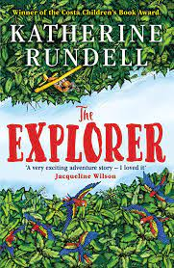  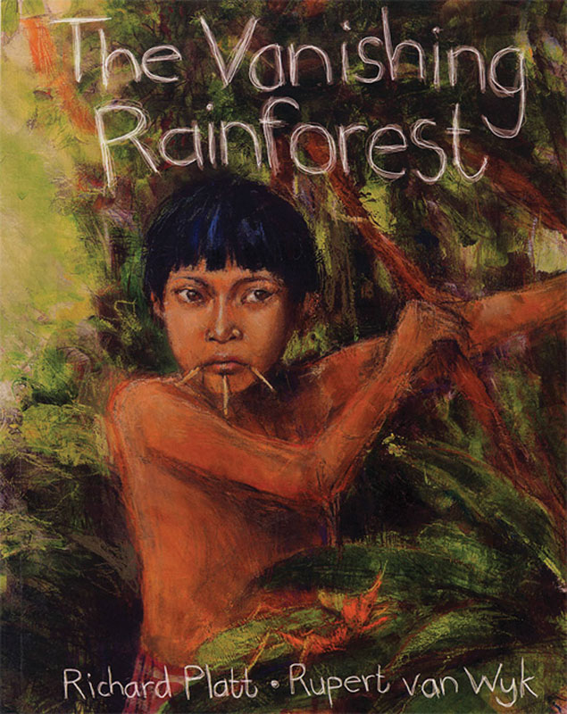 |  | CLPE book  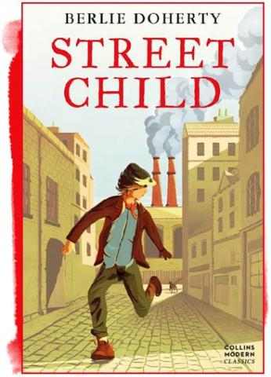  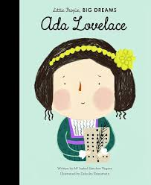 | CLPE book  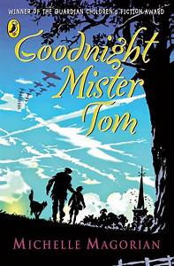  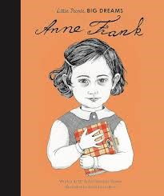 | CLPE book 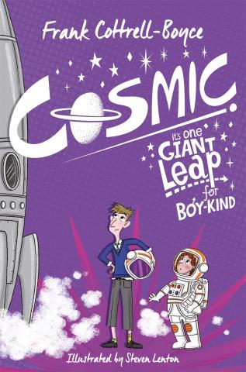  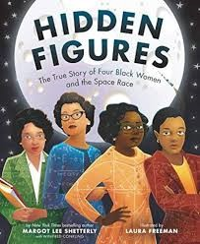 | CLPE book  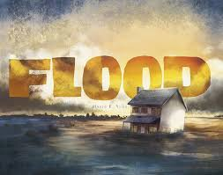  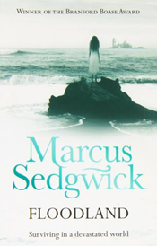 | CLPE book  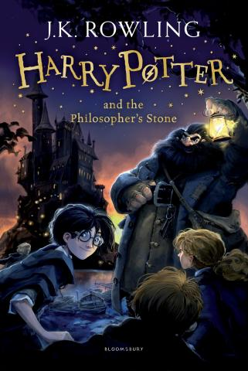  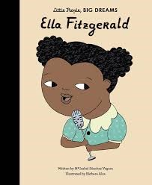
Enrichment Opportunity | Make terrariums – children to create their own rainforest biome inside a self-contained ecosystem. |  | Trip to Kelmscott Manor – to complete William Morris printing workshop – History/Art.  Then use the inspiration to create lino print canvas bags at school. | WW2 VE Day –  History/ Design Technology. | Trip to Space Centre/Planetarium | Trip to Harry Potter World as inspiration ready for next term. | Trip to Osmington Bay – PE Harry Potter Themed Day – cut willow wands, dragon eggs, science magic potions, sorting house fortune tellers, quill writing.
Narrative  Text:  Genre/Plot  Focus: |  | Narrative  -Journals in role as character  -Narrative  Non-Narrative  -Information leaflet in Amazon  -Radio Broadcast  -Persuasive writing – letter | Narrative:  -Character profiles  -Drama- freeze-frames, hot-seating  -Diary writing  -Narratives – story scene  Non-Narrative:  -Arguments – Should the workhouses be closed?  -biography | Narrative  -Diary entry  -Character analysis  -Drama  -Narrative  Non-Narrative  -Poetry – evacuee poem  -Newspaper – outbreak of war  -Persuasive writing – poster  -Information leaflet – life on the home front  -Instructions – How to build an Anderson shelter  -Book and film review – comparison | Narrative  Character Descriptions  Narrative writing  Diary  Setting descriptions  Drama – hot seating  Non-Narrative  Instructions – How to care for Glib | Narrative  -Portfolio of character descriptions  -Extended writing. Sequel about Zoe.  Non-Narrative  -Write a letter to Zoe  -Discussion – Is Dooby a good leader?  -Persuasive writing. Persuasive letter – who should Zoe save? | Narrative  Character description  Non-Narrative:  -Formal letter – invitation to Hogwarts  -Advert – new magic wand  -Non-chronological report - magical creature, using Fantastic Beasts and Where to find them  -Poem – about their new magical creature
Grammar |  | -Full stops and capital letters  Y5:  - Coordinating conjunctions (greater bulldog bat, bowerbird)  -Subordinating conjunctions (European hamster)  Y6  -Dictionary skills – (agama lizard, warthog)  -Using a thesaurus (Nile crocodile, sponge) | Y5  -Similes (Grevy’s zebra)  -Expanded noun phrases (Languar Monkey)  -Fronted adverbials (brown bear, sally lightfoot crab)  Y6  -Expanded Noun Phrases (banded mongoose, tarpon)  -Figurative Language (whooper swan) | Y5  -Tense Consistency (meerkat)  -Active and Passive Voice (anglerfish, elephant seal)  -Modal verbs  (hawksbill turtle, lynx)  Y6  -Passive Voice (Grey squirrel)  Modal verbs (Asian elephant, Magellanic penguin)  -Perfect verb form (Cassiopeia jellyfish, grizzly bear) | Y5  -Direct Speech (giraffe, harpy eagle, walrus)  Y6  - Colons for lists (Indian giant squirrel, locust, flying fish)  -Bullet points (King Penguin, Sumatran rhino, tazmainina devil)  -Informal speech - (e.g. He’s your friend, isn’t he?), Subjunctive forms – If I were, Were they | Y5  -Possessive apostrophe’s (orang-utan, chimpanzee)  -Commas to clarify meaning (humpback whale)  - Semi-colons (anaconda)  Y6  – Semi-colons (silver ants)  -Commas to clarify meaning (Namaqua chameleon)  - Hyphens (grey mullet, racoon) | Y5  -Relative clauses (mudskipper)  -Parenthesis (pebble toad)  Y6  -Relative Clauses (banana frog)  -Parenthesis (bull shark, red flying fox)  -Proof reading (Spinner dolphin, cuttlefish)
Spelling |  | 6  -Dictionary  -LKS2 statutory words  -UPKS2 statutory words  -Plurals  -Regular verb ending  -Irregular verb endings | 6  -Shun sounding words  -Ant and ent  -ible able  -cious tious cial tial | 5  -Word families  -cious tious  -tial cial  -ant ancy ance  -ent ency ence  -ible ibly able ably | 5  -ive ic ist  -fer  -suffixes  -misspelt words | 6  -Suffixes  -Prefixes  -ology phobia  -Abstract nouns | 6  -morphemes  -origins Greek, French, Indian  -literary terms
Reading  (cf Reading Spine) |  | Journey to the River Sea By Iva Ibbotson | The Unadoptables by Hannah Tooke  Oliver Twist By Charles Dickens | War Horse (GR) By Michael Morpurgo  Carrie’s War (GR) By Nina Bawden  Blitzcat (GR) BY Robert Westall  Varmints by Helen Ward  My War Diary By Flossie Albright | Curiosity: The Story of a Mars Rover | Happy Here: 10 Stories from black British authors  Why the Whales Came By Michael Morpurgo | Harry Potter and the Chamber of Secrets  Harry Potter and the Prisoner of Askaban
Maths |  | Number:  Place Value  Addition and subtraction  Multiplication and Division | Number:  - Fractions  Multiplication and Addition | Number:  - Multiplication and Division  - Fractions  Decimals | Measurement  Area, perimeter and volume  Number  - Decimals  Fractions, decimals and percentages | Ratio  Algebra  Geometry:  Shape | Geometry  Position and Direction  Statistics  Measurement  Converting units
Science |  | Living things and their habitats  Describe how living things are classified into broad groups according to common observable characteristics and based on similarities and differences, including micro-organisms, plants and animals  Give reasons for classifying plants and animals based on specific characteristics. | Light  Recognise that light appears to travel in straight lines  Use the idea that light travels in straight lines to explain that objects are seen because they give out or reflect light into the eye  Explain that we see things because light travels from light sources to our eyes or from light sources to objects and then to our eyes  Use the idea that light travels in straight lines to explain why shadows have the same shape as the objects that cast them | Earth and Space x 2  Describe the movement of the Earth, and other planets,  relative to the Sun in the solar system  Describe the movement of the Moon relative to the Earth  Describe the Sun, Earth and Moon as approximately spherical bodies  Use the idea of the Earth’s rotation to explain day and night and the apparent movement of the sun across the sky | Earth and Space x 2  Describe the movement of the Earth, and other planets,  relative to the Sun in the solar system  Describe the movement of the Moon relative to the Earth  Describe the Sun, Earth and Moon as approximately spherical bodies  Use the idea of the Earth’s rotation to explain day and night and the apparent movement of the sun across the sky | Animals including humans.  Describe the changes as humans develop to old age.  Identify and name the main parts of the human circulatory system, and describe the functions of the heart, blood vessels and blood  Recognise the impact of diet, exercise, drugs and lifestyle on the way their bodies function  Describe the ways in which nutrients and water are transported within animals, including humans. | Forces  Explain that unsupported objects fall towards the Earth because of the force of gravity acting between the Earth and the falling object  Identify the effects of air resistance, water resistance and friction, that act between moving surfaces  Recognise that some mechanisms, including levers, pulleys and gears, allow a smaller force to have a greater effect
Geog |  | South America:  -Human and physical features  -Capital cities  -Weather and Climate  -Layers of the rainforest  -Rainforest animals  -Tribes of the forest  -Deforestation-climate change  -Palm oil  Understand geographical similarities through a study of human and physical geography of a region within North/South America (Brazil and the Amazon)  On a world map locate the main countries in the Americas and identify their main environmental regions, key physical; and human characteristics, and major cities.  Name and locate countries and capital cities of the world and explain where they are in relation to one another. |  | Link to History about WW2- Locate and study the major countries involved in WW2 (UK, Germany, Poland, Italy, Japan, USA). Link to our locality of Wootton.  Field study – how was Wootton involved in WW2? Look at where the plane landed and map out. | Earth  LIink to Science - Use the terms latitude, longitude, Equator, North and South Hemisphere, Tropics of Cancer/Capricorn, Arctic/Antarctic Circle and time Zones  Name and locate countries and capital cities of the world and explain where they are in relation to one another. | The UK Farming –  Human Geography: including land use, economic activity including trade links, and the distribution of natural resources including energy, food, minerals and water.  Sustainability  Global Warming  Climate Change  Human impact on the planet. Look at how the climate has changed over time and how global warming is affecting the Earth.
History |  |  | What was it like to be a child in Victorian times?  -All about the life of a Victorian  -Timeline, chronological order  -Victorian Life  - Children at work in the Victorian Era  -Workhouses  -Victorian Schools  -Comparing modern and Victorian School life  -Lives of the rich and poor  -Victorian Inventors  A study of an aspect or theme in British history that extends pupils’ chronological knowledge beyond 1066. a significant turning point in British history | How did people get on with life in the Blitz? X2  -The Battle of Britain  -Churchill and key moments of the war  -Home front  -Anne Frank and the Holocaust  -VE Day: End of the War in Europe  - The Blitz  - Air raid shelters  - All about WW2  - Propaganda posters  - Evacuation  A study of an aspect or theme in British history that extends pupils’ chronological knowledge beyond 1066. a significant turning point in British history, for example, the Battle of Britain |  |  | Leisure and entertainment  -At the movies  -The Beautiful Game  -The swinging sixties  -Wish you were here  -The gogglebox  -Technology
Art |  | South American art:  - Artists Frida Khalo  - Mixed media birds: water colour, stenicls, collage and acrylic paint pens with stencils. | Printing  -Victorian artist study: William Morris  - Printing  - Print tiles, canvas bags  - Lino printing | Artist study L S Lowry  Pencil and line drawings  -War posters  -Design a character for propaganda poster e.g Mr Carrott  -Blitz perspective picture | Artist Study Peter Thorpe  -rocket and planet pastel pictures | Seaside art:  -David Hockney wate artist  - Create pictures of water.  -Water colour paintings
D&T |  |  | Light up Victorian house  -Design  -Make  -Electrics and switch  -Evaluate | Cooking  WW2 VE Day café  Design and make dishes which could have been created using rations. |  | Recycle/ Re-use  Children to design and make and re-purpose things to create something new. | Fairground Rides  Building structures Understand and use electrical systems in their products
RE |  | UNDERSTANDING C+  UC Concept:  God  Key Question: What does it mean (for Christians) if God is holy and loving?  Religion: Christianity | UNDERSTANDING C+  UC Concept: Incarnation  Key Question: Was Jesus the Messiah?  Religion: Christianity  Alternate… DISC.RE Theme: Christmas  Key Question:  Do Christmas celebrations and traditions help Christians understand who Jesus was and why he was born? | DISCOVERY RE  Theme:  Belief into action  Key Question: How far would a Sikh go for his/her religion?  Religion: Sikhism  (Y5 p11-16) | UNDERSTANDING C+  UC Concept: Salvation  Key Question: What  difference does the  resurrection make for  Christians?  Religion: Christianity | DISCOVERY RE  Theme:  Beliefs and moral values  Key Question: Are Sikh stories important today?  Religion: Sikhism  (Y5 p 25-28) | DISCOVERY RE  Theme:  Prayer and Worship  Key Question:  What is the best way for a Sikh to show commitment to God?  Religion: Sikhism  (Y5 p38-42)
MFL |  | French  5 – School Life | French  5 – Time Travelling | French  6 – Let’s Visit a French Town | French  6 – More to Explore | French  6 – Our Precious Planet | French  6 – This is France
Computing |  | Y5 – Computing Systems and Networks – Systems and Searching  1.Systems  2.Computer systems and us  3.Searching the web  4.Selecting search results  5.How search results are ranked  6.How searches are influenced | Y6 – Computing Systems and Networks – Communication and Collaboration  1.Internet addresses  2.Data Packets  3.Working Together  4.Shared Working  5.How we communicate  6.Communicating responsibly | Y5 – Creating Media – Introduction to Vector Graphics  1.The Drawing Tools  2.Creating Images  3.Making effective drawings  4.Layers and objects  5.Manipulations Objects  6.Create a vector drawing | Y6 – Creating Media - 3D Modelling  1.Introduction to 3D Modelling  2.Modifying 3D objects  3,Make your own name badge  4.Make a desk tidy  5.Planning a 3D model  6.Make your own 3D model | Y5 – Programming B – Selection in quizzes  1.Exploring Conditions  2.Selecting outcomes  3.Asking questions  4.Plannming a quiz  5.Testing a quiz  6.Evalulating a quiz | Y6 – Programming B – Sensing Movement  1.The mico:bit  2.Go with the flow  3.Sensing inputs  4.Finding your way  5.Desiging a step counter  6.Making a step counter
Music |  | Music and Technology  How does music bring us together? | Enjoying Musical Styles  How does music teach us about our community? | Musical Styles Connects Us  How does music teach us about our community? | Sing and Play in Different Styles  How does music connect us with our past? | Melody and Harmony in Music  How does music bring us together? | Farewell Tour  How does music connect us with the environment?
PE |  | Fundamental movement skills 5 | Travelling and jumping 5 | Balance, shape, rotation 5 | Dance – Fundamentals 6 | Dance - Maypole | Celebration of Sport 6
PSHE |  | 5 Me and me Relationships  -Collaboration challenge  -Give and take  -How good a friend are you?  -Relationship cake  -Being assertive  -Emotional needs  -Communication | 6 Valuing difference  -Ok to be different  -We have more in common than not  -Respecting differences  -Tolerance and respect  -Advertising friendships  -Challenging gender stereotypes | 5 Keeping Safe  -Thinking about habits  -Jay’s dilemma  -Spot bullying  -Ella’s diary dilemma  -Decision dilemma  -Play, like, share | 6 Rights and Responsibilities  -Two sides to every story  -Fakebook friends  -What’s it worth?  -Jobs and taxes  -Action stations  -Project pitch | 5 Growing and Changing  -How are they feeling?  -Taking notice of feelings  -Fear Hetty  -Changing bodies and feelings  -Growing up and changing bodies  -Help I’m a teenager get me out of here  6- Growing and changing  -Helpful or unhelpful: managing change  -I look great  -Media manipulation  -Pressure online  -Is this normal?  -Dear Ash  -Making babies  -HIV | 6 Being My Best  -This will be your life!  -Our recommendations  - What's the risk? (1)  -What's the risk? (2)  -Basic first aid, including Sepsis Awareness  -Five Ways to Wellbeing project

