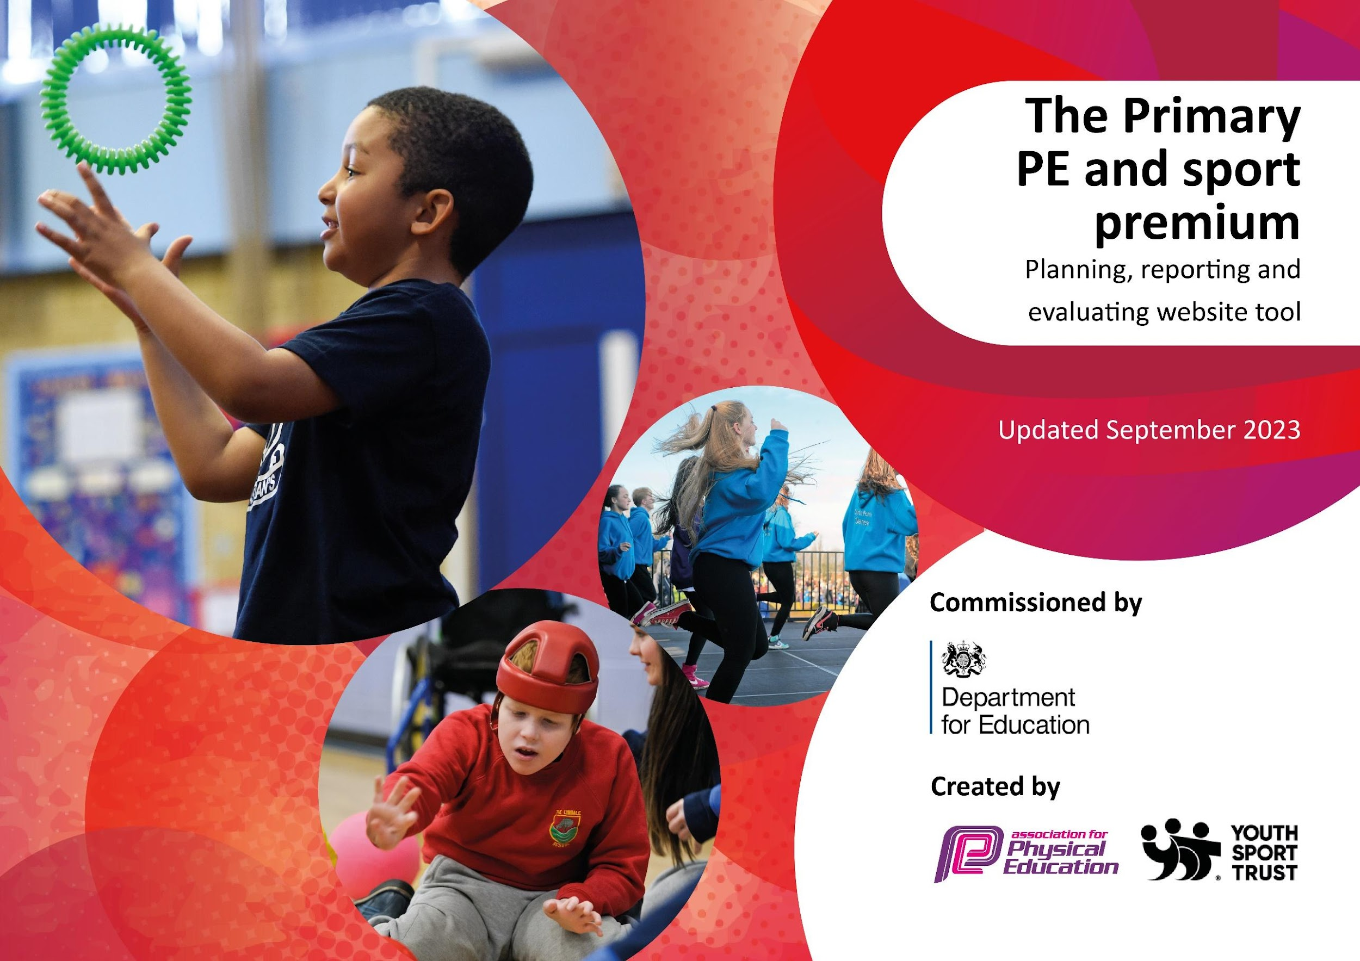

Review of last year’s spend and key achievements (2023/2024)

Reflection on the impact of current provision and reviewing your previous spend.

Activity/Action | Impact | Comments
Aim 1: To ensure all PE lessons are high quality, where all children make progress  - High quality PE lessons delivered to the whole school from Cleal’s wheels.  - Coaches filled out assessment sheets at the end of each term, so we could monitor and track progress and skills throughout the year. PE lead evaluated effectiveness and met with the coach at the start of each term to discuss areas for development for each term.  - All children in Early Years have received cycle training to progress from a balance to a pedal bike.  - Teachers have utilised REAL Jasmine PE, for their second indoor PE lesson, including the skills of dance and gymnastics.  - Teachers have monitored and tracked progress, via the REAL PE assessment wheels. These have been shared with PE lead and updated throughout the year.  Aim 2: Offer a wide variety of sports beyond the school day  - Opal Class have had a partnership with the Manor Prep School. They had a term of PE lessons delivered at the Manor Prep School.  - Whole school participated in a cricket day in February, to learn new skills.  - After school football club for KS2 has been successful with Kalvin and run on a Tuesday and Wednesday.  - Charlotte has run street dance club in the Autumn term,. They also have put on performances to the local community in the community centre.  - Children in Moonstone class participated in bikability cycle training.  - During December the whole school participated in the imoves dance advent calendar.  - Opal class went to a hockey festival at The Manor Prepatory School.  - Whole school PE day on July 16th. The children got to try some new sports like archery. They had five different fun and exciting PE lessons throughout the day: skate boarding, crazy golf, archery, yoga and inflatables.  - Children in UPKS2 participated in a lunchtime fitness club on a Tuesday lunchtime with the sports coach.  - The whole school participated in walk to school week 20th-24th May. Children were encouraged to walk, ride or scoot to school every day to try and stay fit and active. They received a badge for joining in on all 5 days.  Aim 3: Participate in competitions throughout the year.  - PE Coordinator attended local partnership meetings throughout the year, to discuss partnership events and competitions.  - KS2 participate in the Cross Country Running Competition at Tilsley Park as part of the Vale Partnership.  - One Y6 pupil, has gone on to compete in the indoor athletic inter county finals.  - At the end of term 1, the whole school participated in an intra-school hockey competition. Each year group played in their house teams in a competitive match. The points were combined for each house team across all year groups.  - UPKS2 have participated in a small schools football league. The children have participated in six matches throughout the year, where they have played competitively against other schools in the area.  - UPKS2 participated in class basketball competition. They were awarded a gold medal if they core score 20 points (everyone did)!  - On 7th March, a team of 9 children from Y5/6 participated in a netball tournament.  - At the end of May the whole school competed in an intra-school tennis tournament.  - Y3-4 competed in red tennis tournament at the WHLC and came third place.  - On the 5th June Y5-6 competed at the Orange tennis competition at the WHLC.  - On the 12th June Y3-4 competed in the QuadKids Athletics competition at Tilsely park.  - On the 13th June Y5-6 competed in the Quadkids Athletics Competition at Tilsley Park. | - The coach has delivered excellent lessons where the children have been engaged and motivated throughout the lesson. Lessons are broken down into steps and misconceptions are identified and re-modelled.  - They have all made excellent progress throughout the year. All children can now use a cycle bike.  - Videos and photographs have been used to show progress and for the children to reflect back and see how they can improve.  - The children really enjoyed the lessons and it also provided our ECT with some lesson demonstrations from an expert teacher.  - It was a great opportunity for children to learn new skills from an expert.  - Children were able to put their new skills into practice in the small schools football league.  - The children really enjoy it and have progressed a lot over the term.  - This proved them with the skills to be able to cycle safely on the road.  - The children enjoyed brining some PE into the curriculum every day, and the wake up shake up Christmas themed danced also provided a brain break to stimulate learning in other subjects.  - The children were exposed to a range of new and exciting sports. Better provision to ensure we instil the sporting passion for every child in school.  - Promote healthy active lifestyle and promoting the 30 minutes of exercise every day.  - All children in the school have had the chance to compete in competitive sport this year.  - We have earnt the Bronze Award in Sainsbury’s school games this year, which shows our dedication and commitment to school sports.  - Every term the children have the opportunity to participate in competitive sports and to feel like part of a team. They have been able to apply their knowledge and skills to competitive games.  - The children could recognise their progress and success. They won all 5 matches and didn’t concede any goals. Not only did they win the tournament, but they were recognised as the team that showed both the best teamwork and the most honest.  - The children came in third place.  - OW r came top scoring boy and won first place out of over 300 children there. He also met the UK National Athletics Bronze award.  - MW came fifth out of over 300 children there. He also met the standard for the UK National Athletics Gold Award. KG came 17th out of all the children there and met the standard for the UK National Athletics Silver Award. | - Next academic year move to one term of cycle training for Little Gems, rather than 3 terms.  - PE lead to investigate and look for an alternate PE scheme for the next academic year which is all in one document so easier to follow.  - PE lead to liaise with other independent schools to see their offer for the next academic year.  - Bikability training booked for next academic year – October.  PE lead to look into netball leagues/tournament for next year.

Key priorities and Planning

Action – what are you planning to do  Who does this action impact? | Key indicator to meet | Impacts and how sustainability will be achieved? | Cost linked to the action
- High skilled sports coach, to deliver PE once a week alongside a member of staff.  - Purchase access to twinkl PE plans to support teachers in delivery PE. Access to high quality resources and PE mastery planning..  - Children in KS2 to complete the great figure of 8 running every day.  - KS2 Fitness Club at lunchtime.  - Multi-skills club, after school for children in year 1 -6. Whole school encourage all children to join in with regular after school sports clubs.  - After school football club for year 1 – 6. Whole school to be encouraged to join in with regular after school sports clubs.  - Use Democratic Circle time, to captures the whole school voice on how we could develop sport at break and lunchtimes.  - In March Years 1-6 to participate in a tennis taster lesson, run by the White Horse Leisure Centre coaches.  - Yoga session for year 5/6, to focus on using yoga as a tool for mindfulness and de-stressing.  - Increase girls participation in football. Target girls only football - Year 3-4 to participate in a girls only football tournament. Kelvin to run some girls only football training sessions.  - PE lead to map out the sports across the year, in line with the national curriculum, to ensure a broad and balanced range of sports on offer.  - Cycle training for children in Little Gems.  - Cycle training for UPKS2 – the children to complete four 2 hour sessions in road safety and cycling, to pass their cycling ability badge, with Bikeability.  - Collect pupil voice, to plan clubs and sports provision.  - On the 12th February 10 children from KS2 to take part in a dance festival at King Alfred’s school.  - The whole school to learn dances for May day and perform their May pole dances to an audience of their parents and members of the local community.  - 15th July – whole school PE day. The children to have the opportunity to participate in a range of different, creative sports. This was very successful last year.  - Kalvin to run a weekly football club for the football team to help train and prepare them for competitions and the football league.  - UPKS2 to compete in the Abingdon small schools football league.  - UPKS2 to attend indoor athletics competition at St Helen and St Catherine’s school in November.  - In March KS1 to attend multi-skills festival at John Mason secondary school.  - KS1 to attend a cricket festival, to learn new skills and play some mini matches of continuous cricket, against other schools.  - The whole of key stage 2 to attend the Year 3-4 and Year 5-6 quad kids competition in June. Compete in 75m sprint, 600m long distance, standing long jump and howler throw. | 1. Increasing all staff’s confidence, knowledge and skills in teaching PE and sport  2. Increasing engagement of all pupils in regular physical activity and sport  3. Raising the profile of PE and sport across the school, to support whole school improvement  4. Offer a broader and more equal experience of a range of sports and physical activities to all pupils  5. Increase participation in competitive sport | To ensure longevity the staff have access to the plans and resources being delivered. This will ensure a progressive curriculum across the school, which will be easy to follow and is skills focused  This will help children to stay fit and healthy throughout more of the school the day.  Fully funded after school sports clubs, to ensure equal access for all.  Children will become fitter and healthier.  Clubs are able to continue to be run and are fully funded to ensure that all children can attend.  Children to receive a voucher for a free session at the White Horse Leisure Centre, so they can continue the new skills learnt at school, outside of school as well.  Whole school PE activity day.  This year, cycle training to be in the summer term to ensure longevity of previous cycle training in the early years.  Help to prepare children ready for secondary school and to provide them with the confidence to cycle to school.  This will be a great opportunity for children to try a different sport and show their creativity.  All children to have equal access to compete in competitive sports, this year.  All the children to have the opportunity to demonstrate excellent team work, great sportsmanship and resilience. | £715.50  £1560  £2163.40  £95  £7510.50  £1900  £110.87  £360  £660  £1000  £425  £77.50  £101.10  £600

Key achievements 2024-2025

Activity/Action | Impact | Comments
Aim 1 - Increased confidence, knowledge and skills of all staff in teaching PE and sport  - School bought access to twinkl PE plans to support teachers in delivery PE. Access to high quality resources and PE mastery planning. This ensures a progressive curriculum across the school, which is easy to follow and is skills focused.  - Mr Cleal to support and teach in PE lessons for one hour a week. This ensured high quality provision alongside our school staff. Maths lead met with Me Cleal to look at plans and how to use the scheme to ensure a progressive curriculum.  - PE Lead completed Inclusive Heath Check with SGO in the autumn term, this helped to identify key groups of children and to ensure that our sports offers are inclusive for all.  - In term 5 the class teachers were up-skilled in their cricket skills teaching; a coach came in Tuesday mornings in Term 5, 22nd April to 20th May to teach an hours’ cricket to each class.  Aim 2 - The engagement of all pupils in regular physical activity  - Children in KS2 complete the Golden Miles – great figure of 8 every day.  - KS2 Fitness Club at lunchtime. This helped children to stay fit and healthy throughout more of the school the day.  - Multi-skills club, after school open for children in year 1 -6. Whole school encouraged to join in with regular after school sports clubs. The children really enjoyed the club, as they tried new sports such as a term of archery.  - After school football club open from year 1 – 6. Whole school encouraged to join in with regular after school sports clubs. We have now developed equal opportunity for girls and boys and we have several girls on our school football team.  - In Democratic Circle time, the whole school shared their voice on how we could develop sport at break and lunchtimes, They came up with some ideas for games, which the sports leaders ran and decided which new equipment, they would like to enhance sport provision at breaktimes.  Aim 3 - The profile of PE and sport is raised across the school as a tool for whole-school improvement  - In March Years 1-6 participated in a tennis taster lesson, run by the White Horse Leisure Centre coaches. The children learnt new skills and had fun playing the tennis games. The coaches also gave all the children a voucher for a free session at the White Horse Leisure Centre.  - Yoga session for year 5/6, focusing on using yoga as a tool for mindfulness and de-stressing. The children really enjoyed the session.  - All the girls in Year 3-4 participated in a girls only football tournament and made it through to the finals. Kelvin ran some girls only football training session for them, which they really enjoyed, hence improving both their physical and mental wee-being.  Aim 4 - Broader experience of a range of sports and activities offered to all pupils  - PE lead mapped out the sports across the year, in line with the national curriculum, to ensure a broad and balanced range of sports on offer.  - Cycle training for children in Little Gems. This year it has been for the summer term to ensure longevity of previous cycle training in the early years.  - Cycle training for UPKS2 – the children completed four 2 hour sessions in road safety and cycling, passed their cycling ability badge, with Bikeability. Parents fed back complementing the session, on how it’s helped to prepare their children ready for secondary school and had provided them with the confidence to cycle to school.  - After collecting the pupil voice, the children really enjoyed the archery last year on the sports PE day, so we have made a whole term of archery in the multi-skills club after school.  - On the 12th February 10 children from KS2 took part in a dance festival at King Alfred’s school. This was a great opportunity for children to try a different sport and show their creativity.  - The whole school learnt dances for May day and performed their May pole dances to an audience of their parents and members of the local community.  - 15th July – whole school PE day. The children had the opportunity to participate in a range of different, creative sports.  Aim 5 - Increased participation in competitive sport  - Kalvin ran a weekly football club for the football team to help train and prepare them for competitions and the football league.  - UPKS2 competed in the Abingdon small schools football league. We played 7 matches against other schools throughout the year. The children elected their own football captain, who helped to organise the team positions, tactics and the kit.  - UPKS2 attended an indoor athletics competition at St Helen and St Catherine’s school in November. All children in UPKS2 had equal access to compete in the competitive sports.  - In March KS1 attended a multi-skills festival at John Mason secondary school.  - KS1 attended a cricket festival, where they learnt some new skills and got to play some mini matches of continuous cricket, against other schools.  - The whole of key stage 2 attended the Year 3-4 and Year 5-6 quad kids competition in June. They got to compete in 75m sprint, 600m long distance, standing long jump and howler throw. All the children demonstrated excellent team work, great sportsmanship and resilience.  - Year 3-4 girls attended a football tournament and made it through to the finals in Oxford.  - Year 3-4 attended red tennis event at the White Horse leisure Centre.  - Year 5-6 attended orange tennis event at the White Horse Leisure Centre.  - At the end of each term, Mr Cleal had run an intra-school sports competition, by splitting each class into their house teams. They have earnt points, which have then accumulated together to determine the winning House team. The trophy has then been presented in celebration assembly.  - Sports day events, planned organised and run by sports leaders. | - Having a clear, progressive PE scheme, ensure high quality PE lessons.  - Staff are confident to teach PE, and have high quality videos to use as WAGOLLS for PE lessons.  - Having a coach to support PE lessons, has enable staff to enhance their specific skills and knowledge.  - Staff have learnt new skills and ideas from the coaches, which they can implement in their own lessons.  - Children participate in sports beyond the two hours of PE.  - Children are active and developing skills at break and lunch times as well.  - Fully funded clubs, have enable equal access for all children. Good up-take in clubs and places are full.  - KS2 complete the great figure of 8 running every day.  - PE and sports not only benefit the children in their fitness and having fun, but also aid concentration in the class.  - The new PE curriculum has enabled a broad and balanced variety of sports on offer to all year groups.  - Cycle training has been sustainable this year, as we have reduced it from every week in the previous year, to the summer term this year. All children leave EYFS being confident on bikes. This has developed up throughout the school to moving to bikability training and the children being confident to cycle on the roads, when they leave primary school. This is a valuable life school, as lots of them will cycle to their secondary school.  - After the success from the PE day, where children had the opportunity to try archery across the school, we have now embedded this into our after school multi-skills club.  - We have been awarded the School Games Gold Award this year, to show our dedication and commitment to school sports.  - Year 3-4 girls had the opportunity to play football in competitive sport, they were coached by Kalvin and sports leaders at breaktimes. They said they really enjoyed it and would like to continue to play football.  - All children have participated in competitive sports events throughout the year.  - The children have enjoyed being sports leaders and have coached each other at breaktimes. This has helped to develop their leadership skills. | - Keep PE plans to support staff in their second PE lesson.  - Look at after school clubs, do we need a girls only day – after the success with the girls only football training sessions?  - Develop a movement break in KS1 and EYFS – could this be a dance wake up shake up?  - Liasie with after school club providers to ensure archery can continue for the next academic year, as the children have really enjoyed it.  - Cycle training (bikability) booked for October next academic year.  - Attend partnership meetings and create a calendar of events, which we can attend next academic year.

Swimming Data
Meeting National Curriculum requirements for swimming and water safety.
Priority should always be given to ensuring that pupils can perform safe self-rescue even if they do not fully meet the first two requirements of the National Curriculum programme of study

Question | Stats: | Further context  Relative to local challenges
What percentage of your current Year 6 cohort can swim competently, confidently and proficiently over a distance of at least 25 metres? | 100%
What percentage of your current Year 6 cohort can use a range of strokes effectively [for example, front crawl, backstroke, and breaststroke]? | 100% | Children receive school swimming lessons in year 3-4. If they have not met the standards, they go for top up swimming lessons in year 5 and 6. This has had a positive impact on their swimming ability.

What percentage of your current Year 6 cohort are able to perform safe self-rescue in different water-based situations? | 100%
If your schools swimming data is below national expectation, you can choose to use the Primary PE and sport premium to provide additional top-up sessions for those pupils that did not meet National Curriculum  requirements after the completion of core lessons. Have you done this? | Yes/No | Three of our children had not met the swimming requirements at the start of year 6, so we used some top up lessons to get them to the required standards.
Have you provided CPD to improve the knowledge and confidence of staff to be able to teach swimming and water safety? | Yes/No | Staff attended a swimming course to improve their skills, knowledge and water safety - £95.

Signed off by:

Head Teacher: | Charles Pitt
Subject Leader or the individual responsible for the Primary PE and sport premium: | Carina Phillips  PE Lead
Governor: | (Name and Role)
Date:

