PE Funding

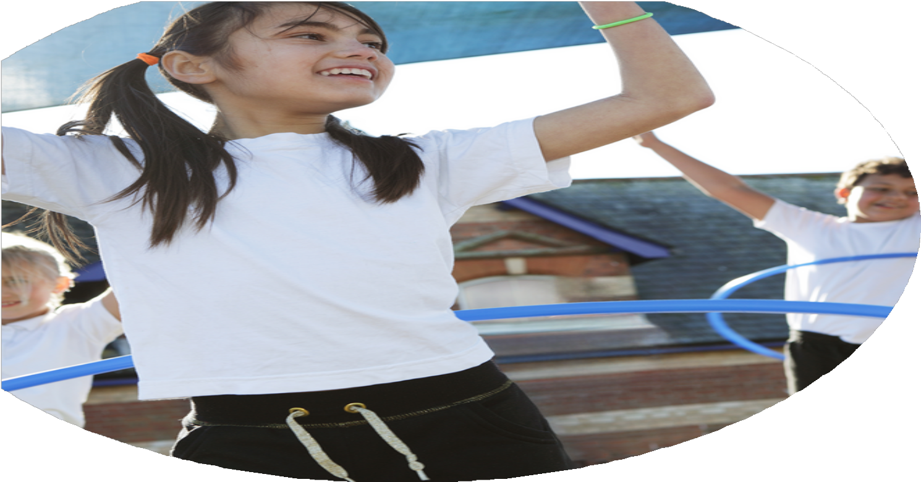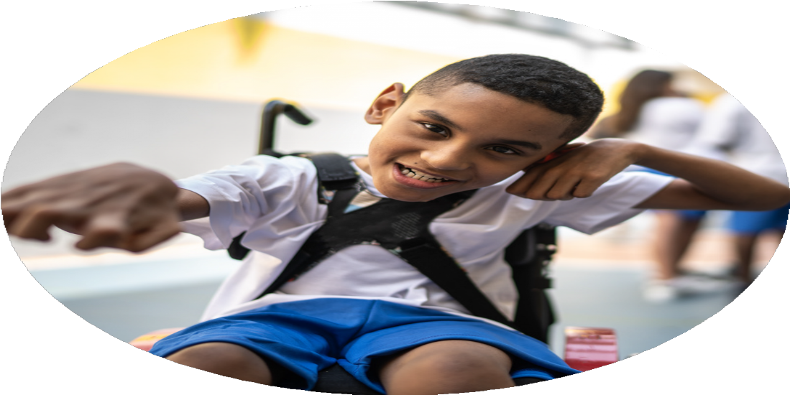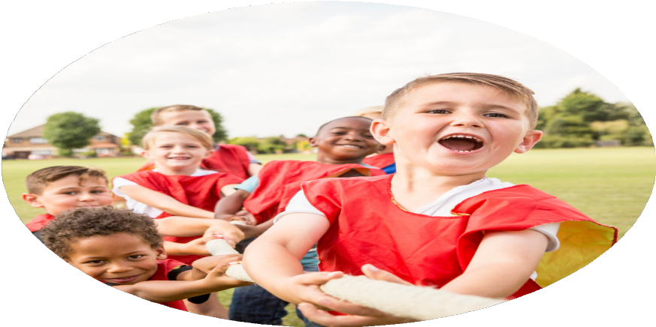

Evaluation Form

**Commissioned by**

**Created by**

Images courtesy of Youth Sport Trust

* Discussions with staff, staff meetings and questionnaire.
* Staff have found the REAL PE plans and scheme tine consuming and hard to follow. We purchased this 3 years ago, but it hasn’t been as successful as we had hoped.

• Lesson plans and observations show that the coach has delivered excellent lessons where the children have been engaged and motivated throughout the lesson. Lessons are broken down into steps and misconceptions are identified and re-modelled.

• Observations, photographs and AFL notes show that they have all made excellent progress throughout the year. All children can now use a cycle bike.

• Videos and photographs have been used to show progress and for the children to reflect back and see how they can improve.

**Aim 1: To ensure all PE lessons are high quality, where all children make progress**

* High quality PE lessons delivered to the whole school from Cleal’s wheels.
* Coaches filled out assessment sheets at the end of each term, so we could monitor and track progress and skills throughout the year. PE lead evaluated effectiveness and met with the coach at the start of each term to discuss areas for development for each term.
* All children in Early Years have received cycle training to progress from a balance to a pedal bike.
* Teachers have utilised REAL Jasmine PE, for their second indoor PE lesson, including the skills of dance and gymnastics.
* Teachers have monitored and tracked progress, via the REAL PE assessment wheels. These have been shared with PE lead and updated throughout the year.

What are your plans for 2024/25?

Intent

How are you going to action and achieve these plans?

Implementation

* Coaches to support in to support PE lessons
* High skilled sports coach, delivers PE once a week alongside a member of staff.
* To ensure good attendance target less active and girls groups to attend clubs. Speak to parents and send out letters. Establish a girls only football o aching session.
* Children will become fitter and healthier.
* All children in KS2 to engage with ‘great future of 8’ running everyday. This will also act as a movement break, which will not only enchancing children’s physical skills, but will also aid their concentration in class.
* To ensure longevity the staff have access to the plans and resources being delivered. This will ensure a progressive curriculum across the school, which will be easy to follow and is skills focused
* This will help children to stay fit and healthy throughout more of the school the day.
* Fully funded after school sports clubs, to ensure equal access for all.
* Children will become fitter and healthier.
* Clubs are able to continue to be run and are fully funded to ensure that all children can attend.
* Children to receive a voucher for a free session at the White Horse Leisure Centre, so they can continue the new skills learnt at school, outside of school as well
* Whole school PE activity day.
* This year, cycle training to be in the summer term to ensure longevity of previous cycle training in the early years.
* Help to prepare children ready for secondary school and to provide them with the confidence to cycle to school.
* This will be a great opportunity for children to try a different sport and show their creativity.
* Ensure all PE lessons are delivered to a high standard.
* Fully fund after school sports clubs to that all children including PP, SEN and less active, are able to attend after school sports clubs, without any barriers
* Sports and movement to be incorporated into every day.
* All pupils to participate in PE beyond the two hours
* Develop sports leaders so children can run clubs at break and lunchtimes.
* High skilled sports coach, to deliver PE once a week alongside a member of staff.
* Purchase access to twinkl PE plans to support teachers in delivery PE. Access to high quality resources and PE mastery planning..
* Children in KS2 to complete the great figure of 8 running every day.
* KS2 Fitness Club at lunchtime.
* Multi-skills club, after school for children in year 1 -6. Whole school encourage all children to join in with regular after school sports clubs.
* After school football club for year 1 – 6. Whole school to be encouraged to join in with regular after school sports clubs.
* Use Democratic Circle time, to captures the whole school voice on how we could develop sport at break and lunchtimes.
* In March Years 1-6 to participate in a tennis taster lesson, run by the White Horse Leisure Centre coaches.
* Yoga session for year 5/6, to focus on using yoga as a tool for mindfulness and de-stressing.
* Increase girls participation in football. Target girls only football - Year 3-4 to participate in a girls only football tournament. Kelvin to run some girls only football training sessions.
* PE lead to map out the sports across the year, in line with the national curriculum, to ensure a broad and balanced range of sports on offer.
* Cycle training for children in Little Gems.
* Cycle training for UPKS2 – the children to complete four 2 hour sessions in road safety and cycling, to pass their cycling ability badge, with Bikeability.
* Collect pupil voice, to plan clubs and sports provision.
* On the 12th February 10 children from KS2 to take part in a dance festival at King Alfred’s school.
* The whole school to learn dances for May day and perform their May pole dances to an audience of their parents and members of the local community.
* 15th July – whole school PE day. The children to have the opportunity to participate in a range of different, creative sports. This was very successful last year.
* Kalvin to run a weekly football club for the football team to help train and prepare them for competitions and the football league.
* UPKS2 to compete in the Abingdon small schools football league.
* UPKS2 to attend indoor athletics competition at St Helen and St Catherine’s school in November.
* In March KS1 to attend multi-skills festival at John Mason secondary school.
* KS1 to attend a cricket festival, to learn new skills and play some mini matches of continuous cricket, against other schools.
* The whole of key stage 2 to attend the Year 3-4 and Year 5-6 quad kids competition in June. Compete in 75m sprint, 600m long distance, standing long jump and howler throw.

What impact/intended impact/sustainability are you

expecting?

How will you know? What **evidence** do you have or

expect to have?

* Percentages of children attending, and focus children will attend clubs; check club registers, and speak to club coaches.
* Monitor ‘great figure of 8’ running. This could be timetabled into weekly lesson plans or timetable.
* Complete Subject Leadership Monitoring Form.
* Complete lesson observations and learning walks.
* Complete impact report.
* Complete sports premium pending report.
* Complete PE photo log, with photos of sports events and lessons.
* Last year we achieve the school games bronze award, this year aim to achieve the silver school games award.
* Youth sports leaders plans and game designs – children will have the opportunity to take leadership and ownership of their own sporting events.
* Youth sports leaders to help organise teams ready for competitive sports events , including sports day.
* Video recordings of snippets of lessons.
* Coach reflections from lessons.
* AFL annotations on plans, and post it notes made during lessons.
* Engage with PE partnership meetings and collect meeting minutes and information about sports competitions and opportunities.
* Create year planner for mapping out sports competitions which we can attend.
* Share events in school diary and online calendar.
* More children to attend an after-school sports club. Clubs to continue to be fully funded, to ensure that they are accessible for all children.
* All children to engage in extra physical activity every day.
* Twinkl plans will enable all classes to develop progressive PE plans over the two-year rolling cycle. Map out the units for mixed year groups over both years.
* To engage with the school games more, so children can participate in a broader range of competitive sports.
* Continue with the cycle training in EYFS to ensure sustainability from when it was introduced two years ago. Move to the summer term as children in reception are now confident so need less training. All children in nursery will be able to confidently use a balance bike and some will begin to use pedal bikes.
* Children in UPKS2 to take on the role of sports leaders. Children to elect a sports captain. Children will have the opportunity to plan and run their own sports events and training.
* LKS2 to run coaching sessions at break time to help the girls football team
* Children to have the opportunity to try new sports in sports PE day.
* After the success of the PE day last academic year, ensure sustainability of archery. Archery to be taught in the autumn term in multi-skills club
* Kelvin to coach children, in after school sports club, to help them prepare for league matches.
* Children to be active every day, through lunch clubs, after school clubs, great figure of 8 running and movement breaks built into the school day.
* Y6 pupils to continue sports at secondary, which they have been passionate about.

What **impact/sustainability** have you seen?

What **evidence** do you have?

* Subject Leader monitoring form.
* Lesson Plans – to monitor for lessons taught to a high standard.
* PE photo logs.
* Pupil voice captured in whole school democratic circle time, see meeting minutes.
* Club registers.
* Results and certificates from sports competitions and events we’ve been too.
* Certificate and logo to show school games gold award.
* PE Impact Form.
* School newsletters, which report on competition results.
* PE skills progression document.
* Sports trip letters and permission slips sent to parents.
* Fixtures dates for football tournaments.
* Invoices to track spending.
* Meeting minutes from sports partnership meetings.
* Lesson observations.
* Sports leaders plans for games and sports events to be run; instructions and layout plans, which they’ve created.
* PE yearly overview.
* Achieved School Games Gold Award, to show our dedication to school sport and competitions.
* Year 3-4 girls football team, really benefited from their targeted coaching and go through to the county finals at Oxford.
* Less active children were targeted and attended dance event at King Alfred’s. They found a sport, which they loved. Now joined street dance after school sports club.
* Cycling training is more sustainable, moved from every week to the summer term, this helps with costing and still enables the children to learn the required skills in reception. This is sustainable as it moves on to bilk ability and getting the children confident to cycle their bikes on the road. This is a valuable life skill, as lots of the children will cycle to their secondary school.
* Successful links established with partnership schools, which have provided numerous opportunities to engage in competitive sports.
* Teachers downloaded the PE plans and resources they want for PE lessons.
* When coaches have been used to support reliever of high quality PE lessons, this has enabled the class to split into smaller groups for more focused teaching. This has also been beneficial to split into mini matches, where an adult can lead and coach each team. To ensure longevity the staff have access to the plans and resources being delivered.
* Teachers follow the twinkl PE scheme and lessons are progressive over the term. The video help to act as WAGOLLS for staff.
* The whole id KS1 and KS2 have engaged with interschool competitive sports this year.
* Whole school PE day enabled children to try new sports to instill them with a passion for the rest of their school life.