Wootton St Peter’s CE Primary School



**Teaching and Learning Policy**

**Date Adopted by Governing Body: September 2024**

**Date to be Reviewed: September 2025**

**Signed Chair of Governors**



***Mike Varnom***

**Signed Headteacher**



***Charles Pitt***

**Wootton St Peter’s Teaching and Learning Policy**

**Introduction**

At Wootton we strive to achieve a level of excellence in all that we do. Providing high quality teaching and learning is the core purpose of our school. Continued and sustained school improvement is dependent upon improving the quality of teaching and learning that is taking place on a daily basis. Across our school the expectation is that all children are provided with high quality learning experiences that lead to consistently high levels of pupil achievement. Our expectation is that all teaching staff are excellent; reflecting on learning outcomes and always willing to improve for the benefit of the children. Therefore, this policy is a live document that can be regularly revisited and updated to reflect changes to pedagogy and improvements that we have made.

***How We Learn at Wootton*** incorporates a growth mindset, we all have an optimism that we can and will succeed and achieve a level of excellence. We build confidence so we can meet challenges with enjoyment and make progress. Lessons are designed so that children experience challenge and are kept in the ‘learning or stretch zone’.

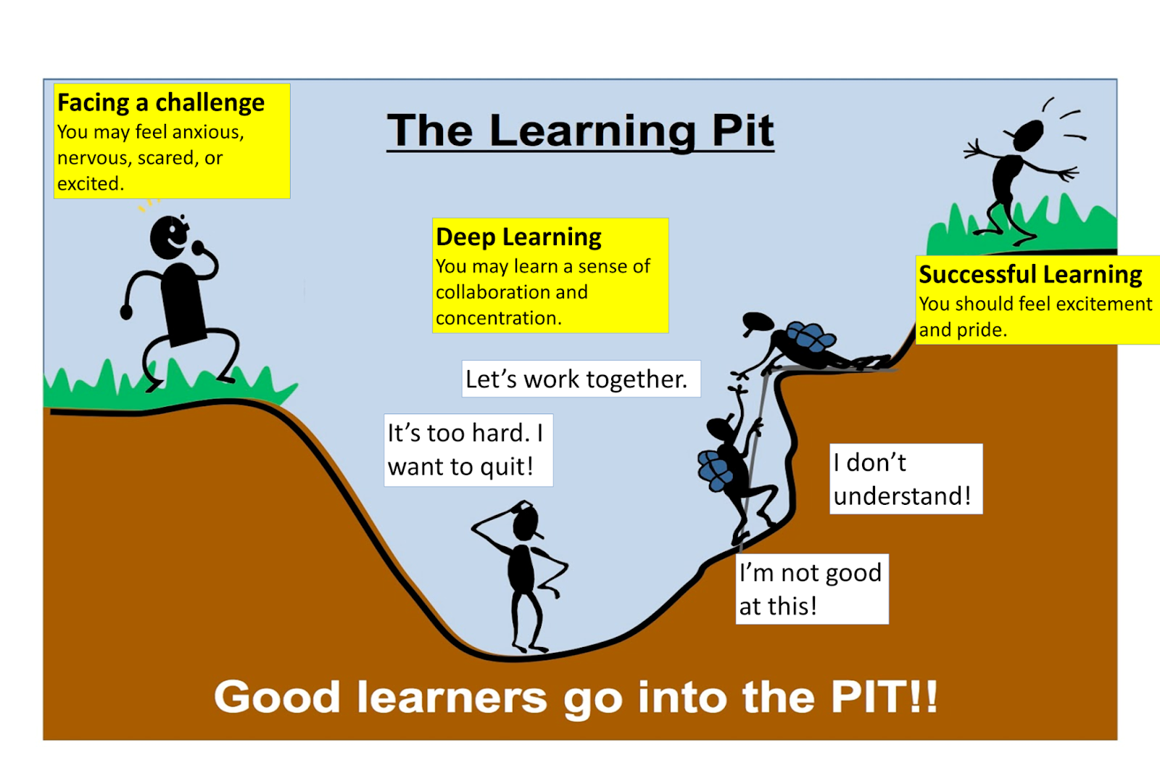

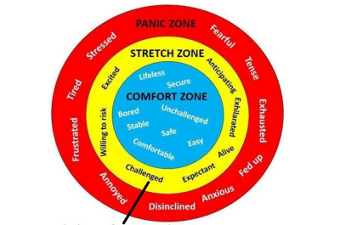

***Where we want our pupils to be***.

We explore the ‘Learning Pit’ so that children understand that deep learning should be challenging and that being in the stretch zone means that they are actively learning. We equip them with skills to enter the pit with courage, to persevere to tackle their learning and to have compassion with themselves and others

Children are conscious of their thinking, they are able to find solutions to problems and facilitate and develop open minded thinking. They learn more and so achieve good results, they have the cultural capital to succeed and they are building towards the next stage of their education. **At Wootton St Peter’s our children become the rocks upon which a better world can be built. We explore the values of perseverance, compassion and courage to open up horizons of hope and aspiration.** We are committed to developing independent learners and responsible citizens with a clear vision for the future.

**Purpose of this Policy**

This policy outlines some of the key elements which are fundamental to raising standards in teaching and learning. It aims to set out a broad organisational structure for lessons, based on best practice and research linked to how we best learn. However, we do not advocate a prescriptive approach as it is important that children have the opportunity to experience creative teaching approaches and all members of the school community are able to use their own creative and spontaneous flair to express themselves as individuals.

The key elements to successful teaching and learning at Wootton are:

**PURPOSE,** **EXPECTATION AND** **CHALLENGE,** **EXPLANATION,** **MODELLING,** **PRACTICE,** **QUESTIONING, FEEDBACK**

Teachers skilfully use these elements to inform the use of Assessment for Learning. AfL informs planning and drives the learning as teachers use their knowledge of the child and extensive subject knowledge to ensure pupils are kept in the stretch zone.

**PURPOSE**

* Lessons should have a clear learning focus and objective so pupils know what they are learning and why.
* These verbs are used to write learning objectives as they encourage higher order thinking:

*analyse apply classify compare connect contrast create describe discuss elaborate examine explore identify interpret judge observe organise paraphrase predict respond support represent visualise reason sequence simplify solve summarise synthesise*

* Specific success criteria or steps to success are provided to enable pupils to do well and for them to evaluate against.
* Listening partners are clear about what they should be discussing to be successful
* Learning fits within a context and is meaningful. The purpose and audience of the finished product is carefully considered. Learning is scaffolded across a series of lessons and there is a clear outcome and learning sequence.

**EXPECTATION AND** **CHALLENGE**

* High expectations of pupils’ learning and behaviour are firmly embedded. These are reflected in teachers’ planning and practice.
* Pupils’ respond very positively to these high expectations. They are fully focused on their learning, productive and make rapid gains in their learning. They take care and pride in their work.
* No lids are put on the expectations of any child’s learning; we assume that they will be able to achieve the objectives, regardless of history or habit.
* Excellence is a habit and target for all children.
* Challenging tasks are set which are well matched to pupils’ abilities, with assessment information aiding this. Pupils’ interest is sustained and they make rapid progress in acquiring knowledge, deepening their understanding and applying skills.
* Tasks are continually monitored, modified and adapted, and achievement is assessed ‘live’, to allow for maximum attainment from every child during a lesson.
* All children are pushed to their full potential by ensuring their tasks are not limited or restricted.

**EXPLANATION**

* Children’s prior knowledge and experience is used as a hook into new learning.
* Links are made to previous learning and other areas of the curriculum.
* All possible opportunities to make the explanation clearer are capitalised upon – for example demonstrating with concrete resources, pictorial representations or drama techniques.
* Explanations are clear and concise.
* Technical vocabulary is used to enhance understanding.
* Misconceptions are managed through prediction and swift identification.
* Relatable connections are made so that explanations are accessible.
* Pupils are given the opportunity to explain their understanding to each other and to teaching staff
* ‘Just tell them’. Questioning for understanding a is a vital ingredient of teaching, however when teaching new skills or knowledge it is important to reduce time wasted with answers that aren’t based on prior learning.
* Create mystery and hook the learners by planting questions and asking for predictions to make children curious about the learning to come.

**MODELLING**

* Use a visualizer for live modelling and demonstrate your thinking out loud
* Question our assumptions about what children know and adapt our modelling accordingly
* Set high standards and provide the path to attaining that excellence.
* Show what your expectations are relentlessly. Every behaviour, task, routine and transition should be modelled and demonstrated to the children.
* Routines are modelled effectively:
  + - Break the routine down into small stages and create a detailed visual guide
    - Keep instructions brief and make them a habit
    - Consider replacing verbal instructions with numbers and accompany these with visual clues
    - Replace the numbers with visual clues only
    - Practice against the clock
* Demonstrate the struggle – ensure that the children see you taking time and thinking about what you are demonstrating. The children need to witness the development of how you arrive at the choices you make and the decision that you take
* Build one together – continue to demonstrate the struggle and your thought processes and invite contributions from the children. Children should be encouraged to explain their thinking and choices
* Give children time to talk- hearing the correct language modelled followed by time to practise. Drama techniques can be very beneficial here.
* Prepare one earlier- preparing a model in advance gives the teacher control over the process and allows teaching staff to anticipate misconceptions and where they may require further support. It enables analysis, deconstruction and evaluation of the learning.
* Use examples of excellence –keeping and sharing examples of excellence by former pupils is a great way to set high expectations and show children what they are capable of achieving. It can also be deconstructed then used to show that by responding to feedback and careful editing, work can be made to be excellent compared to its first draft
* Modelling mistakes – include children in the metacognitive processes needed to correct the mistakes – explain your choices and think out loud
* Use an expert- video footage, parents, professionals- It can create awe, wonder and inspiration.

**PRACTICE**

* Give children plenty of time to engage in practice activities after being exposed to a new concept – **keep children in the stretch zone.**
* Give the children practice activities that encourages them to think hard and lead to independence.
* Regular practice of new learning ensures it is transferred to the long term memory for quick recall.
* Interweave practice of previous learning and new learning
* Repetition is really important, but deliberate practice is about raising the bar each time.
* Scaffold and supports should be used to aid practice and then be removed in a timely way to allow them to build independence
* Give children to orally rehearse and talk about their learning before writing.
* Use websites such as SPAG.com and Manga High to give more time for practice.
* Use the first few minutes of a lesson to practice previously learnt material – quizzes, grid questions, Answer it – Prove it- Explain it questions, Odd one out, What went wrong- children identify the mistakes and correct them.
* More quizzes and low stakes testing – the purpose is for teachers to know how their classes are progressing and then how best to challenge the children appropriately. They enable teaching staff to evaluate how effective the teaching has been and then to adapt it accordingly.
* Mistakes are used as key aspect of learning and are celebrated as such.

**QUESTIONING**

* Use a range of questions to encourage higher order thinking

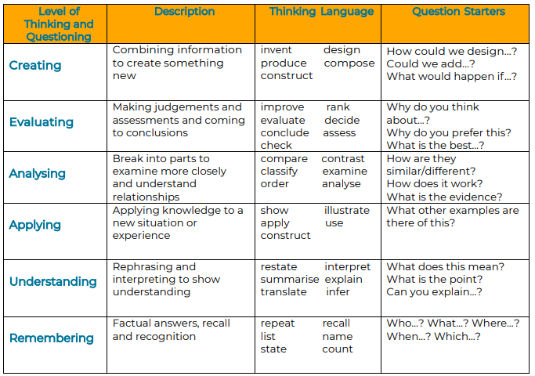

* We aim to have all children engaged all of the time and use different strategies to achieve this. There is an expectation that all children should be ready with an answer.
* We are aware of how long we give children to answer a question: 3 seconds for a recall question and 10 seconds for more open questions.
* Listening partners are used so that children can orally rehearse answers and to aid more participation.
* Whiteboards are used so that all children can show a response.
* Random responders are generated by named lolly pop sticks.
* Use follow up questions to keep children challenged and in the struggle zone
* We aid all children to opt in by being ready to adapt our questions:
  + rephrasing
  + breaking it into chunks
  + give the pupil options to select
  + ask another child and then return to the original child to repeat the answer
* We encourage children to listen and respond to each other through use of listening partners and:
  + Create a why chain
  + Bounce the questions – pose a question to one pupil and then ask the next question to another pupil
  + ABC feedback – ask the pupils to Agree with, Build on or Challenge another child’s answer. We insist on full sentences using formal language

**FEEDBACK**

*We believe that responding to a child’s piece of work is a vital part of the Assessment for Learning process. Verbal feedback ( from an adult or peer) or in written comments should be based upon improving quality and raising standards. Appropriate responses can go a long way to improve motivation as well as identifying clear steps for improvement. The reason for giving feedback is to identify successes, promote progress in the child’s learning and learn from mistakes.*

* The rules for feedback: It should be kind, specific and helpful when critiquing work modelled by the teacher or giving feedback to children. Listening partners follow this rule too.
* Use immediate verbal feedback as much as possible.
* Feedback must be specific, accurate and clear. Link it to the learning objective and success criteria.
* Time taken to write or give feedback must be balanced with the impact it has on the children’s learning.
* Plan for feedback: How will it be organised? Will it be written or verbal? When will the feedback be read, responded to and reflected on? How can it be adjusted to meet any specific needs in the class? Will it be whole class feedback?(see Assessment Strategies below)
* How will it affect what teaching staff model, explain and set for practice? Are my lessons flexible and based on feedback from the performance of the pupils?
* Checking vs marking –this can be more important than long written comments. Once work is checked teaching staff can then decide if written feedback will have an impact or making a note of a misconception to address later will suffice.
* Pupils are expected to read, respond to and reflect on their feedback. This should be modelled throughout the year.
* Model how we behave when we receive feedback – it is a key component of **How we learn at Wootton.** Feedback should foster the growth mindset and children to aim for excellence
* Use a visualiser, video footage or a photo to discuss the effectiveness of the learning being displayed and then give feedback

# Principles for Marking

* Live marking is very effective hot marking. We aim for the feedback go be given live as much as possible. This is because live feedback has the most impact. We do this in different ways: *Use TA, send pupils of in groups, visit groups when you have started off your own group, circulate to ensure groups receive feedback.*
* Not all work is expected to be marked
* Teachers plan when they will do some in depth marking
* Adults and pupils are clear about the learning objective of a task
* Adults and pupils are clear about the success criteria to meet the learning objective
* Constructive suggestions about the way to improve the work are given
* Teachers are selective in the aspects they choose to comment on
* Teachers recognise effort as well as quality linked to specific skills or understanding (learning objective)
* Pupils are encouraged to review their work prior to handing it in. KS1 pupils will need support
* Positive comments for pupils are based on the LO, SC or child’s target
* Pupils are given time to act on feedback –***Purple polishing pen***

**Strategies**

* The lesson objective is recorded or stuck in the children’s books above each piece of work.
* In KS1/2 work is underlined or ticked in pink ***Tickled Pink*** *(achieved) or* ***Green to Grow***, next steps
* In Year 1 and Reception symbols representing targets are used until children are able to read teacher comments
* KS2 use a combination of acknowledgement marking /or in conjunction with teacher comments

A range of strategies are used for peer and self-assessment

* Ticking success criteria grids(SC)
* Using highlighter pens to underline an aspect of the success criteria in writing *Purple pen* to edit and respond to teacher comments

**KS1 Maths and English**

i. Children working with an adult can have acknowledgement marking.

ii.  Children will begin to use self and peer assessment.

iii.  Children start to answer comments by teachers when able; initially this will be with adult support using *purple pen* to respond.

**KS2 Maths**

1. A green dot is placed against a calculation where an error occurs and corrections in *purple pen* may be given as GFG ***green for grow*** – written GFGs are acknowledged by an adult
2. A green circle/underlining is used to denote mistakes or confusion
3. Self-assessments take place both verbally and written using***purple pen*.**

**KS2 English**

i.  Green is used to denote incorrect grammar, punctuation or spelling, when this is an appropriate area to be corrected or a target for that child. Written GFG are acknowledged by an adult.

ii.  Spellings may be practised as part of GFG using ***purple pen***.

iii.  Self and peer assessment takes place verbally and written using *purple pen.*

**KS1 and KS2 Other Subjects**

i.  GFG or peer comment is given if appropriate.

iii.  Self and peer assessment is used when appropriate using ***purple pen*.**

Acknowledgement Marking Codes

VF - Verbal feedback given

WS - With support

I - Independent

PA - Peer assessment

P - Punctuation error on line

SP - Shows a spelling error on that line

It°s raining Circle To show where a punctuation error is

Definate Shows exactly where a spelling error is

**//**  To show where a new paragraph should be

We went shops To show a word is missing

**^**

Acknowledgement Marking

V - Verbal feedback given

T - Teacher supported

TA - Teaching assistant supported

I - independent

**Assessment Strategies**

These are strategies that can be used to ensure that information that is gathered about the children’s learning is accurate and then leads to accurate identification of next steps and enables feedback to improve quality of learning and to raise standards. They should be used to assess pupil’s retention

of the key knowledge identified by teachers in the topic knowledge organisers and planning.

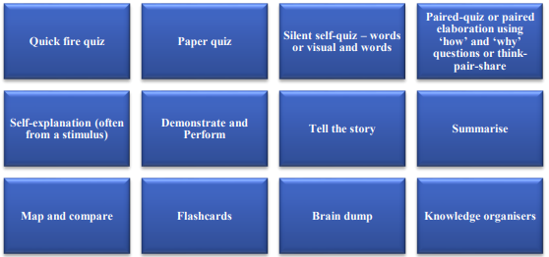

Acknowledgement Marking

V - Verbal feedback given

T - Teacher supported

TA - Teaching assistant supported

I - independent